From: https://www.zerohedge.com/news/2019-04-21/new-study-shocks-electric-cars-considerably-worse-climate-diesel-cars

Electric Car-Owners Shocked: New Study Confirms EVs Considerably Worse For Climate Than Diesel Cars

by Tyler Durden
Mon, 04/22/2019 - 04:15
The Brussel Times reports that a new German study exposes how electric vehicles will hardly decrease CO2 emissions in Europe over the coming years, as the introduction of electric vehicles won't lead to a reduction in CO2 emissions from highway traffic.
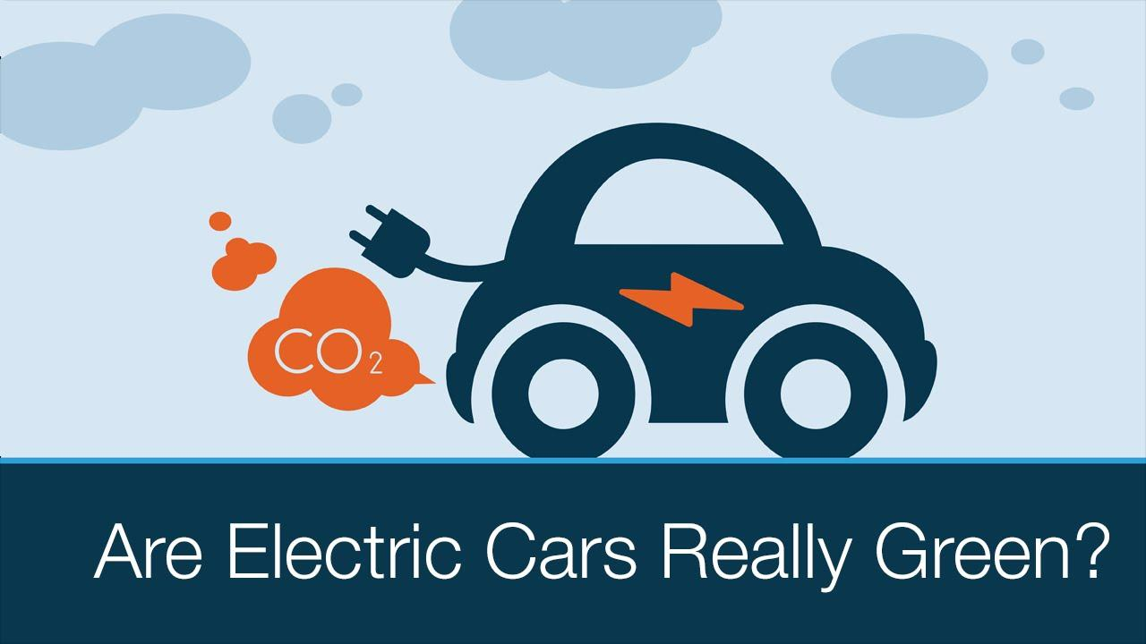
According to the study directed by Christoph Buchal of the University of Cologne, published by the Ifo Institute in Munich last week, electric vehicles have "significantly higher CO2 emissions than diesel cars." That is due to the significant amount of energy used in the mining and processing of lithium, cobalt, and manganese, which are critical raw materials for the production of electric car batteries.
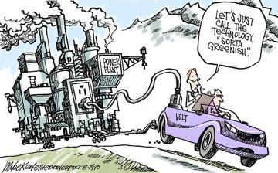
A battery pack for a Tesla Model 3 pollutes the climate with 11 to 15 tonnes of CO2. Each battery pack has a lifespan of approximately ten years and total mileage of 94,000, would mean 73 to 98 grams of CO2 per kilometer (116 to 156 grams of CO2 per mile), Buchal said. Add to this the CO2 emissions of the electricity from powerplants that power such vehicles, and the actual Tesla emissions could be between 156 to 180 grams of CO2 per kilometer (249 and 289 grams of CO2 per mile).
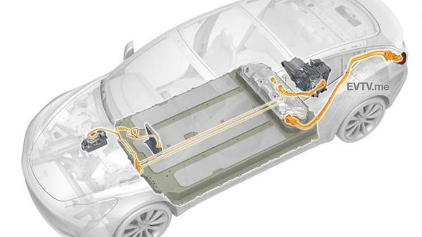
German researchers criticized the fact that EU legislation classifies electric cars as zero-emission cars; they call it a deception because electric cars, like the Model 3, with all the factors, included, produce more emissions than diesel vehicles by Mercedes.
They further wrote that the EU target of 59 grams of CO2 per kilometer by 2030 is "technically unrealistic."
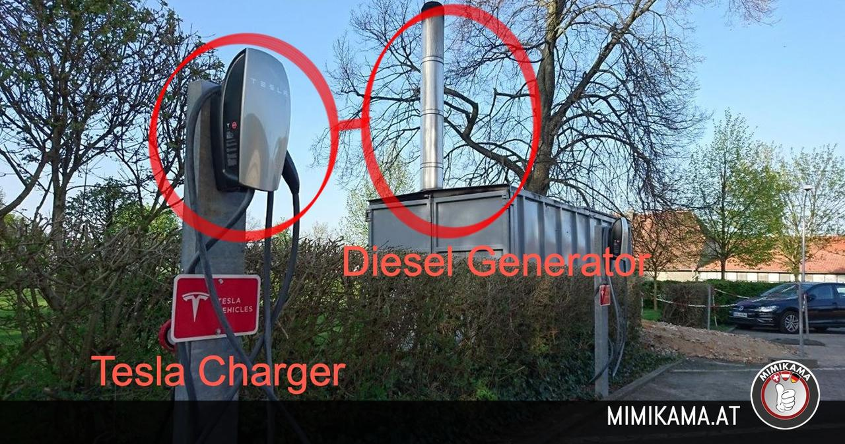
The reality is, in addition to the CO2 emissions generated in mining the raw materials for the production of electric vehicles, all EU countries generate significant CO2 emissions from charging the vehicles’ batteries using dirty power plants.
For true emission reductions, researchers concluded the study by saying methane-powered gasoline engines or hydrogen motors could cut CO2 emissions by a third and possibly eliminate the need for diesel motors.
"Methane technology is ideal for the transition from natural gas vehicles with conventional engines to engines that will one day run on methane from CO2-free energy sources. This being the case, the German federal government should treat all technologies equally and promote hydrogen and methane solutions as well."
So maybe Elon Musk's plan to save the world with electric cars is the biggest scam of our lifetime...

